**Mogaka Sayyid**

**Geodesic distance transform for tortuosity calculation.**

The morphological tortuosity of a geodesic path in a medium can be defined as the ratio between its geodesic length and the Euclidean distance between its two extremities. Thus, the minimum tortuosity of all the geodesic paths into a medium in 2D or in 3D can be estimated by image processing methods using mathematical morphology. Considering a medium, the morphological tortuosities of its internal paths are estimated according to one direction, which are perpendicular to both starting and ending opposite extremities of the geodesic paths. The used algorithm estimates the morphological tortuosities from geodesic distance maps, which are obtained from geodesic propagations.

In image analysis, geodesic distances are used wherever paths linking image pixels are constrained to remain within a subset of the image plane. The region thus defined is called a geodesic mask. For example, when planning the path of a robot, the geodesic mask corresponds to the regions where it can move. Binary geodesic dilations and erosions are closely related to the concept of geodesic distance.

**1. Distance Transforms.**  
  
The ability to measure distance inside an image is made possible by distance transformations. The Euclidean and geodesic distance transforms are the two main types of distance transforms used in image processing and analysis.

The shortest pathways across the pore space are used to calculate the geodesic tortuosity, also known as geometric tortuosity. There are numerous definitions of tortuosity, some of which are based on calculated material qualities like diffusion or electrical conductivity.

***1.1 Geodesic dilation***

A geodesic dilation involves two images: a marker image and a mask image. By definition, both images must have the same definition domain and the mask image must be larger than or equal to the marker image. The marker image is first dilated by the elementary isotropic structuring element. The resulting dilated image is then forced to remain below the mask image. The mask image acts therefore as a limit to the propagation of the dilation of the marker image.

Let denote by *f* the marker image and by *g* the mask image $(D_{f}=D_{g} and f≤g )$ .The geodesic dilation of size 1 of the marker image *f* with respect to the mask image *g* is denoted by $δ_{g}^{\left(1\right)}(f)$ and is defined as the pointwise minimum between the mask image and the elementary dilation $δ^{(1)}$ of the marker image:

*(1)*

$δ_{g}^{\left(1\right)}\left(f\right)=δ^{(1)}(f) Λ g$,

*Marker set Y, Y ⊆ X*

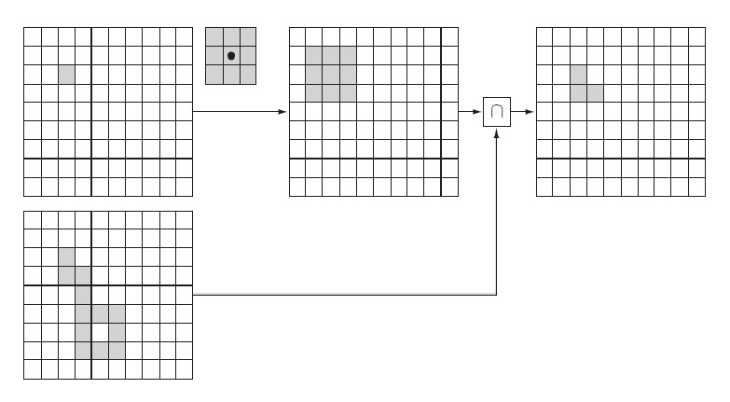

*Geodesic mask X*

*Geodesic dilation $δ_{X}^{(1)}(Y)$*

*Elementary dilation $δ^{\left(1\right)}(Y)$*

*Fig.1. Geodesic dilation of a binary input image or set Y within a geodesic mask X. The marker set is first dilated by the elementary isotropic structuring element and then intersected with the geodesic mask:*

*(2)*

$δ_{X}^{\left(1\right)}\left(Y\right)=δ^{\left(1\right)}(Y)∩X$*.*

Due to the point-wise minimum operator, the geodesic dilation remains lower or equal to the mask image: $δ_{g}^{\left(1\right)}(f)≤g$ From Eq. 1 it can be shown that the geodesic dilation is an extensive operator since the dilation with a structuring element containing its origin is extensive and $f≤g⇔f∧g=f$:

*(3)*

$δ^{(1)}(f)≤f$

*(4)*

$δ^{(1)}(f)∧g≥f∧g$

*(5)*

$$δ^{(1)}(f)≥f$$

It is also an increasing transformation since for all $f^{'} ≤f$ and $g^{'}≤g$ such that $f^{'}≤g^{'}$ and $f≤g$ we have:

*(6)*

$$δ_{g}^{\left(1\right)}(f^{'})≤δ_{g}^{(1)}(f)$$

The increasing property allows the threshold decomposition of the geodesic dilation:

$δ_{g}^{\left(1\right)}\left(f\right)=\sum_{t=1}^{t_{max}}{δ_{{CS}_{t(g)}}^{(1)}[{CS}_{t}(f)]}$ The geodesic dilation of size *n* of a marker image *f* with respect to a mask *g* is obtained by performing *n* successive geodesic dilations of *f* with respect to *g*:

*(8)*

*(7)*

$$δ_{g}^{\left(1\right)}\left(f\right)=δ_{g}^{\left(1\right)}\left(f\right)[δ_{g}^{\left(n-1\right)}\left(f\right)]$$

With $δ_{g}^{(0)}=f$. It is essential to proceed step by step and to apply the point-wise minimum operator after each elementary geodesic dilation in order to control the expansion of the marker image. Indeed, the geodesic dilation is lower or equal to the corresponding conditional dilation:

$δ_{g}^{\left(n\right)}\left(f'\right)≤δ_{g}^{\left(n\right)}(f)Λg$

*(9)*

***1.2 Algorithm Description***

The algorithm makes use of the geodesic dilation. Consider an elementary structuring element defined on the grid of points from a point and its nearest neighbors. It defines a connectivity on the graph generated by the grid, for instance the $C_{4}$ and the $C_{8}$ connectivities starting from a square grid and the 4 or the 8 nearest neighbors, the $C_{6}$ and the $C_{26}$ connectivities on a cubic grid by means of the 6 or the 26 nearest neighbors. Noting $δ(A)$ the dilation of a set A by the elementary structuring element, and $δ_{X}^{(1)}(A)$ the geodesic dilation of size 1 defined from the set *X*, we have:

$δ_{X}^{\left(1\right)}\left(A\right)=δ(A)∩X$

*(10)*

The geodesic dilation of A of size *n* in X is obtained after *n* iterations of $δ_{X}^{\left(1\right)}\left(A\right)$. From its definition, the result of the geodesic dilation depends on the choice of the elementary structuring element (mask) and of its corresponding connectivity.

In our case we consider two defined separate subsets of A and B of the medium X. The geodesic distance of a point $x∈X$ to a subset A.

*(11)*

$$Geo_Dist_{X}(x,A)=min\{Geo_Dist_{X}(xy),x∈X,y∈A\}$$

The geodesic paths connecting x to A are the paths corresponding to Geo_DistX (*x*,A). We put into consideration two parallel planar sources A and B in 3D, and their separation is noted as *Euclidean_Dist (AB*). For every point *x $∈$* X, the morphological tortuosity corresponding to the sources A and B is defined as the ratio Eq. 12.

$Tortuosity _{X_{AB}}(x)=\frac{Geo_Dist_{X}(x,A)+Geo_Dist_{X}(x,B)}{Euclidean_Dist (AB)}$

*(12)*

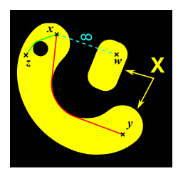

*Fig. 2. The geodesic distance between two points x and y belonging to a medium X*

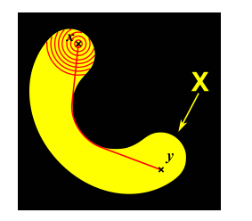

*Fig. 3. Geodesic distance in the set X between x and y estimated by geodesic dilations.*

Thereafter, the morphological tortuosity of each point of a set X (pores) will be estimated via geodesic dilations implemented on a grid of points, since we are using 3D digitized images of a real material (i.e. porous rock).

***1.2.1 Path Reconstruction***

After having defined the source of each voxel of the geodesic mask for both forward and backward propagations of the algorithm estimating the tortuosity, it is then possible to reconnect any components into this mask to both marker faces, even if they have been disconnected by thresholding the tortuosity. The method to process the path reconstruction consists in reconnecting the isolated components to the marker face by using the source images (forward and backward) which indicate the path to follow until the marker faces.

It consists of the following steps using morphological operations, that is, geodesic dilations to estimate the geodesic distance map:

1) Estimation of the geodesic distance of each voxel of the medium X to the face A.

2) Estimation of the geodesic distance of each voxel of the medium X to the face B.

3) Addition of both images.

4) Infinum of both images.

5) Extraction of the percolating paths.

6) Normalization of tortuosity by the Euclidean distance between A and B to get the tortuosity.

This algorithm is shown in 2D by Fig. 4 but its principle is the same in 3D. Let *X* be the set composed of every connected component (white) different from the background in black. Let the top A and bottom B faces be the so-called marker-faces used as markers to be dilated into the set.

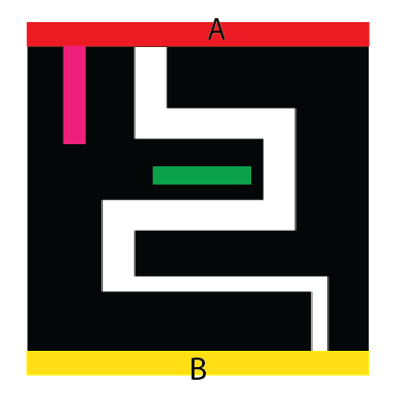

Direction of propagation

*Fig.4. Estimation of the tortuosity into the white set between the top (Red) and the bottom (Yellow) faces.*

The steps 1 and 2 calculate the geodesic distance of each pixel of the set X respectively to the top and to the bottom faces.

The result of step 3, is an image where the value of each pixel of the white component of X is the length of the geodesic path linking the two marker-faces and going through the corresponding pixel.

However, the pixels in the pink components of X are just linked to one marker-face and are then eliminated by steps 4 and 5, which isolate all the pixels belonging to the paths linking the two marker-faces.

Finally the resulting, giving for each pixel the tortuosity of the shortest paths in which it is contained, is then normalized by the Euclidean distance between both marker-faces.

***1.3 On the choice of the mask and marker images***

Morphological reconstruction algorithms are at the basis of numerous valuable image transformations. These algorithms do not require to choose a structuring element nor to set its size. The main issue consists in selecting an appropriate pair of mask/marker images. The image under study is usually used as a mask image.

A suitable marker image is then determined using:

1. Knowledge about the expected result.

2. Known facts about the image or the physics of the object it represents.

3. Some transformations of the mask image itself.

4. Other image data if available.

5. Interaction with the user (Markers are manually defined).

One or usually a combination of these approaches is considered. The third one is the most utilized in practice but it is also the most critical: one has to find an adequate transformation or even a sequence of transformations. Since the marker image has to be greater or less than the mask image, it can be created using extensive or anti-extensive transformations.

**2.Distance Metrics**

A final consideration for the distance transform is how to determine distance. In discrete space, there are generally four standard metrics for distance. The metric used should consider computational expense as well as the accuracy with which the measurement must be made. This is especially important to consider for 3-D data sets as a significant amount of memory and computation time must be invested for large data sets.

Treated as a global operation, EDT can be computed in principle by an exhaustive brute-force search—by calculating for each pixel of the image the distance between that pixel and all other pixels, and computing the smallest distance.

However, such an algorithm would require $A={O(n)}^{2}$ operations (*n* is the number of pixels in the image) and would not be practically suitable. Among more efficient algorithms for calculating EDT are ordered propagation algorithms, raster scan algorithms, and dimension-induction algorithms

In ordered propagation, the distance information is propagated away from the boundary of the object . While such algorithms can be exceedingly fast for simpler metrics , in the case of EDT such algorithms are often affected by numerical errors and can be computationally expensive, while improving their performance can be difficult.

An ordered propagation of the geodesic times is possible thanks to a priority queue of pixels. The algorithm first computes the time necessary to reach the outer boundary pixels of the reference set. Each pixel is then inserted in a queue whose priority level corresponds to the computed geodesic time (fifo_add(pixel, priority level)). The first pixel of the queue having the lowest priority level is then extracted from the queue (fifo_first(priority level)). The geodesic time of each unprocessed neighbor of this pixel is then computed and the corresponding pixel is inserted in the queue whose priority level equals its geodesic time. When there are no more pixels in the priority queue, the geodesic time function is known for all pixels.

**3. Results and Discussion.**

*3.1 The effect of path shape on tortuosity*

Geodesic dilations are morphological operations that are directly influenced by the shape of the structuring element that was used to create the digital image.

 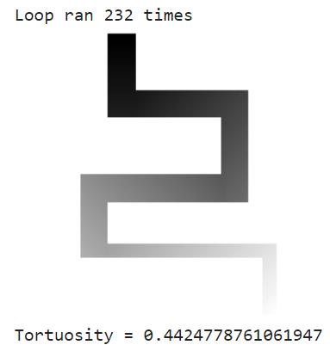

 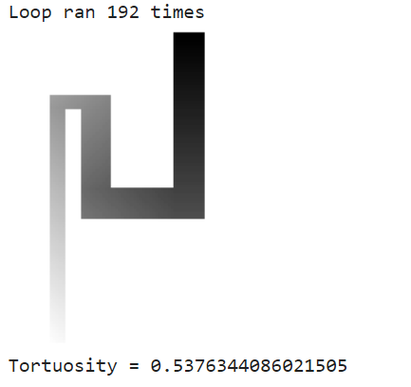

For the simple path models, tortuosity and complexity shows very good correlation. Higher complexity makes tortuosity higher.

*3.2 Size of the mask*

When we consider a straight path through the medium but with different mask sizes,we realize that the tortuosity value is the same for both through the medium X.Consequently,the size of the mask has no significant effect on the tortuosity value.

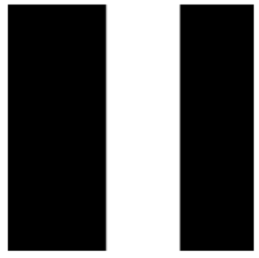 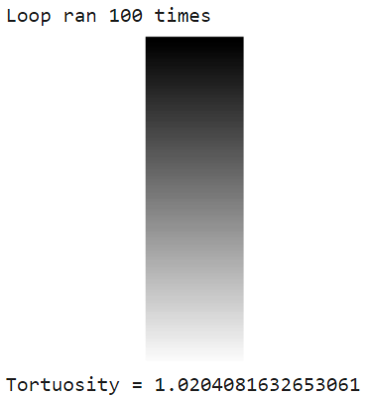

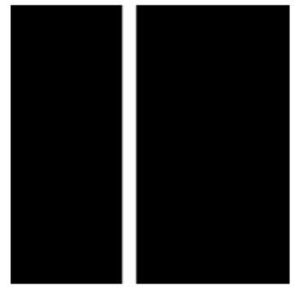 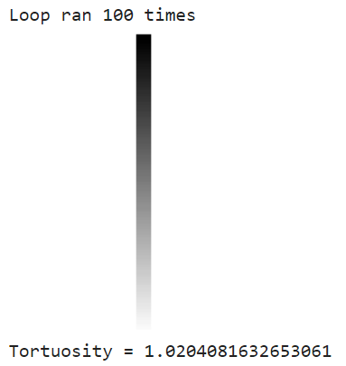

*3.3 Unconnected paths between the face A and B*

When calculating for the geodesic distance of these components, they are eliminated because they are not connected to the marker face and consequently not reached by the propagating fronts in the chosen Oy direction.

However, the pixels here are linked to one marker face, they are eliminated by the step of extraction of the percolating paths, which isolates all the pixels belonging to the paths linking the two marker faces. The tortuosity value hence cannot be considered in our case.

 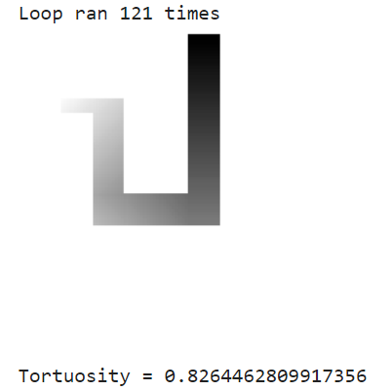

*Connected paths to one marker face*

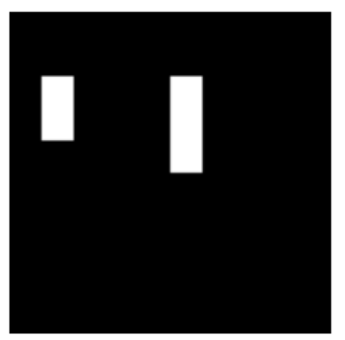 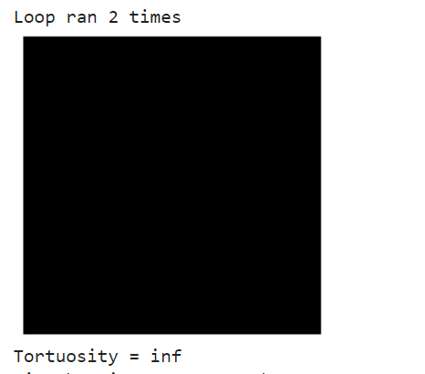

*Unconnected paths*

**4. Conclusions and Future work**

From the performed analysis, we can draw couple of conclusions. Our method to reconnect geodesic paths to isolated connected components lets us locate the geodesic paths within the pores of our material according to their tortuosities.

After having defined the source of each voxel of the geodesic mask for both forward and backward propagations of the algorithm estimating the morphological tortuosity, it is then possible to reconnect any components into this mask to both marker faces, even if they have been disconnected by thresholding the tortuosity.

Estimating the tortuosities of the paths through a medium is highly dependent on the shape of the structuring element used to process the geodesic distances. Moreover they are more sensitive to the discontinuities and changes of directions of the paths through which they propagate. This makes them consequently more accurate in estimating the tortuosities and especially high tortuosities.

The implementation is a brute-force approach to the distance transform. This algorithm is O(n2), as it computes the distance from each background pixel to each foreground pixel. Furthermore, because of the way it is vectorized, it requires a lot of memory.

An efficient algorithm that computes the square of the distance can be proposed, the square distance is separable i.e. can be computed independently for each axis, this leads to an algorithm that is easy to parallelize.

**5. References**

1. Pierre Soille Morphological Image Analysis Principles and Applications
2. *Digital Image Processing* Third Edition *Rafael C. Gonzalez,*University of Tennessee *Richard E. Woods*
3. [https://www.researchgate.net/publication/257731844_A_fast_algorithm_for_computation_of_discrete_Euclidean_distance_transform_in_three_or_more_dimensions_on_vector_processing_architectures?enrichId=rgreq-16af2eb4fc70323448c2beeceb955cde-](https://www.researchgate.net/publication/257731844_A_fast_algorithm_for_computation_of_discrete_Euclidean_distance_transform_in_three_or_more_dimensions_on_vector_processing_architectures?enrichId=rgreq-16af2eb4fc70323448c2beeceb955cde-XXX&enrichSource=Y292ZXJQYWdlOzI1NzczMTg0NDtBUzoxMjIzNjc0NTYwNTkzOTNAMTQwNjE4NjA4MzY5MA%3D%3D&el=1_x_3&_esc=publicationCoverPdf)
4. <https://en.wikipedia.org/wiki/Tortuosity>

# <https://www.academia.edu/7900921/The_determination_of_relative_path_length_as_a_measure_for_tortuosity_in_compacts_using_image_analysis>

Github Repository

<https://github.com/nyangwara/Geometric-Tortuosity-calculation-in-Porous-Media>